Dr Jennifer Alford
DEMCI morning seminar and workshop
Dec 18, 2019, 9.00-12.00

9.00-10.30 Seminar presentation: Using CDA and SFL in Education Research
Critical Discourse Analysis (CDA) within the Education field has a robust record when coupled with understandings of language offered by Systemic Functional Linguistics (SFL). In this presentation, I will provide an overview of CDA and SFL, and the affordances of combining a social view of language as a system of choice (SFL) with the critical lens offered by CDA. Samples of my own data analysis using CDA and SFL, e.g., interviews with teachers; classroom interactions; and policy document extracts will also be shown. I will also outline some of the challenges this approach poses to social researchers interested in the workings of language and analysis of power in differing educational contexts.

10.30-10.45 Coffee Break

10.45-12.00 Workshop with own data: Exploring data using SFL and CDA
In this workshop, I will present foundational concepts used when analyzing data through a linguistically-based critical discourse approach. I will present some examples of my own analysis of education policy documents, interviews with teachers, and classroom interactions. Participants will have the opportunity to explore some of their own data. Please bring laptops and a small section of data to work on and discuss.

About the speaker:
Dr Jennifer Alford (PhD) is a Senior Lecturer in the School of Teacher Education and Leadership, Faculty of Education, Queensland University of Technology (QUT), Australia. She is co-leader of the Literacies, Language, Texts and Technologies Research Group at QUT and has published and presented widely on critical literacy and critical discourse analysis. Her PhD thesis (2015) used CDA and SFL to analyse curriculum documents, classroom interactions and interview data and has won several awards including a 2016 Queensland University of Technology Outstanding Doctoral Thesis Award & the 2015 Penny McKay Memorial Award for Outstanding Doctoral Thesis in Language Education. In 2017, she was a visiting scholar at the Inst för Didaktik & Pedagogisk Profession at Gothenburg University. Recently, Jennifer was guest co-editor for English Teaching Practice & Critique special issue on Teacher Agency. She is a co-founder of the Transnational Critical Literacies Network (TCLN) - a network of over 110 scholars in 20 countries interested in critical literacies.

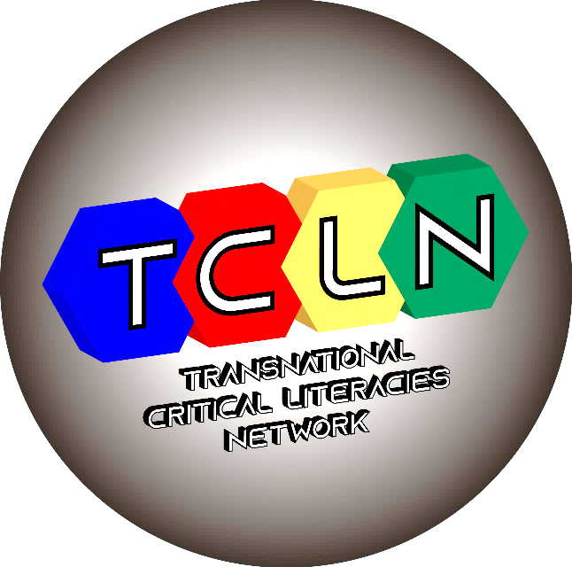

Dr Jennifer Alford
DEMCI afternoon research seminar
Dec 18, 2019, 13.00-15.00

What does critical literacy in English language curriculum look like in five different global contexts? And why does it matter?

In their chapter in the 2015 Routledge Handbook of Literacy Studies, Rogers and O’Daniels called for “studies that trace the emergence and development of critical literacy over time and across contexts”. This presentation reports on my work* that contributes to this call by tracing how critical literacy for English language learners (ELLs) has been conceptualized in English language education curricula (policy) across different global contexts. I will begin with an exploration of the nature of policy - “policy as text” and “policy as discourse”, as noted by Ball (1993, 2015), followed by an explanation of the method used in the policy analysis- Fairclough’s (2003) Critical Discourse Analysis (CDA). Fairclough’s framework provides a way of investigating ideology as it is played out in language within actual practices in social institutions, such as the production of curriculum as policy. CDA is a useful tool to explore the ways that the educational language policies of any country reflect not only social judgements about language, but about other elements as well, such as which groups in society are afforded which educational priorities (McGroarty, 2002; Rogers, 2011). I will present a comparison of how critical literacy is represented and constructed in English language education policy/curriculum for high school adolescent ELLs in five contexts – Queensland, Australia; England; Ontario, Canada; California, USA; and Sweden. The key focus is: what’s in and what’s out for migrant youth, in terms of learning to be critically literate, in the age of standardisation and measurability in education? While there are signs of hope, I argue that the impact of global education reform is contributing to diluted conceptualisations of critical literacy in high school curriculum for English language learners. This dilution compromises the power of literacy education to help migrant youth navigate the complex textual world through critical literacy practices. Discussion will follow.
[*This presentation is based on a chapter in my forthcoming Routledge book: Critical literacy with adolescent English language learners: Exploring policy and practice in global contexts]

Dr Jennifer Alford is a Senior Lecturer in the School of Teacher Education and Leadership, Faculty of Education, Queensland University of Technology (QUT), Australia. She is co-leader of the Literacies, Language, Texts and Technologies Research Group at QUT and has published and presented widely on critical literacy and critical discourse analysis. Her PhD thesis used CDA and SFL to analyse curriculum documents, classroom interactions and interview data and has won several awards including a Queensland University of Technology Outstanding Doctoral Thesis Award & the Penny McKay Memorial Award for Outstanding Doctoral Thesis in Language Education. In 2017, she was a visiting scholar at the Inst för Didaktik & Pedagogisk Profession at Gothenburg University. Recently, Jennifer was guest co-editor for English Teaching Practice & Critique special issue on Teacher Agency. She is a co-founder of the Transnational Critical Literacies Network (TCLN) - a network of over 110 scholars in 20 countries interested in critical literacies.

