Click to enter title.
  - Click to enter subtitle.
by
  - Click to enter author.
Thesis submitted in fulfilment of
the requirements for the degree of
PHILOSOPHIAE DOCTOR
(PhD)
Click to enter faculty.
Click to enter institute.
Click to enter year.
University of Stavanger
NO-4036 Stavanger
NORWAY
www.uis.no
©Click to enter year. Click to enter author.
ISBN: Click to enter ISBN.
ISSN: Click to enter ISSN.
PhD: Thesis UiS No. Click to enter PhD No.

Acknowledgements
Click here to enter text.

Summary
Click here to enter text.
Table of Contents
Acknowledgements iii
Summary iii
1 Introduction 1
2 Theory 2
3 Methodology 2
Appendices 2
Appendix 1 – First entry 2

Table of Figures
Figure 1 – Rolling 1

List of Tables
Table 1 – Participants 2

Appendices
Appendix 1 – First entry 2

Introduction
Click here to enter text.
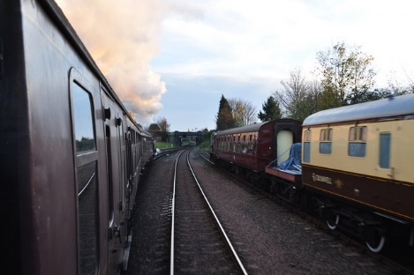
Figure 1 – Rolling

Theory
Click here to enter text.
Name | Address | Postal Code | City
Table 1 – Participants

Methodology
Click here to enter text.

Appendices
- First entry

